**CENTRAL TENDENCY**

**Overall Analysis Report**

* This table presents the statistical summary for a dataset that includes various academic performance metrics (SSC percentage, HSC percentage, Degree percentage, E-test percentage, and MBA percentage) and a corresponding salary figure. Here's a breakdown of the analysis:

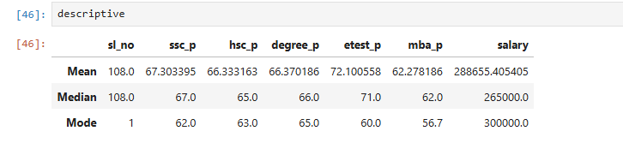

Relationship between Academics & Salary analysis:-

* **Academic Performance:** There is a slight increase in the percentages from SSC to Degree to E-test, but the MBA percentage lags behind the other categories. The scores tend to be centered around certain values, with a few outliers at the lower end (e.g., 60% in the E-test and 56.7% in MBA).
* **Salary Analysis:** The salary data indicates that while most salaries seem to hover around 265,000, there are outliers with higher salaries pushing the mean up. The most common salary is 300,000, which may reflect the salary range for mid-level positions or common salary offers in the dataset's context.
* This same method is useful for various method such as Educational research, Career planning, and Organisational analysis.